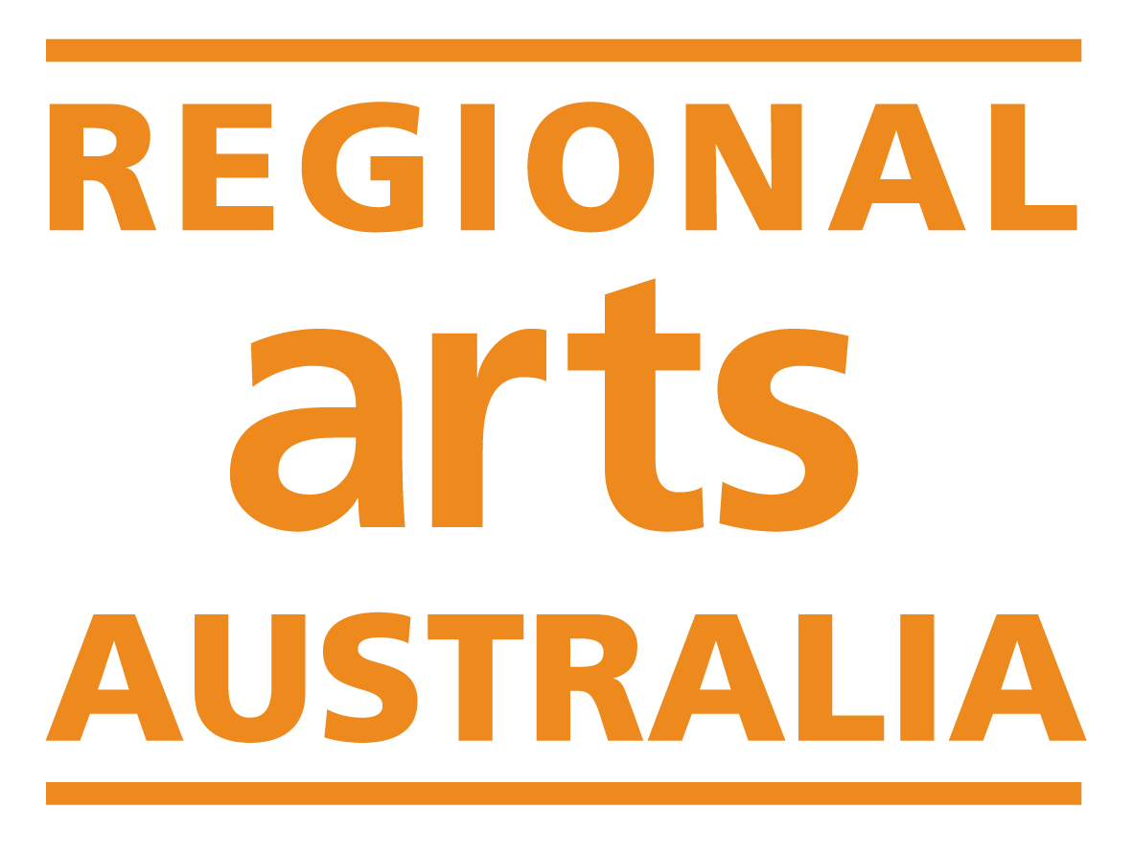

National Regional Arts Fellowship

Expression of Interest Form

Enquiries: | Regional Arts Australia  Grants Manager  rafmanager@regionalarts.com.au  +61 447 204 189

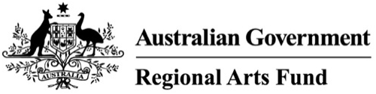

The National Regional Arts Fellowship Program is a strategic project supported by the Regional Arts Fund and delivered by Regional Arts Australia.

Applicant Details

Contact Details
Name:
Email:
Phone Number:
Primary Address:
Postal Address:

Fellowship Category

Select your Fellowship Category
Please select the Fellowship category you are applying to. Please note that applicants to the designated streams will also be automatically considered for the open round fellowships.

Creative & Professional Development $20,000:
Open Round
Aboriginal & Torres Strait Islander applicants
d/Deaf applicants and/or applicants with disability

Early Career Development $10,000:
Open Round
Young People (under 25 years)

If you selected the Early Career Development category, tell us about why you consider your career to be in its early stages (max 150 words):
Enter text here

If you selected one of the Aboriginal & Torres Strait Islander applicant streams, please confirm that you identify as Aboriginal and/or Torres Strait Islander:
Yes, I identify as Aboriginal and/or Torres Strait Islander.
Optional: How do you identify?

If you selected the stream for d/Deaf applicants and/or applicants with disability, please confirm that you have lived experience of d/Deafness and/or disability:
Yes, I have lived experience.
Optional: How do you identify?

Eligibility

What is the MMM code of your Primary Address?
The National Regional Arts Fellowship provides designated funding for individuals that are based in regional areas. Individuals based in metropolitan locations are not eligible to apply.

To determine eligible locations, the fund uses the Modified Monash Model. If you haven't used the Modified Monash Model before, please follow these instructions.

Select your MMM code:
MMM 1: You are not eligible to apply for this funding.
MMM 2
MMM 3
MMM 4
MMM 5
MMM 6
MMM 7

Do you have an active sole trader ABN that is registered to your name and location?
No: You are not eligible to apply in this round.
Yes: Please continue to the next question.

Have you received a National Regional Arts Fellowship in the past five years?
Yes: You are not eligible to apply in this round.
No: Please continue to the next question.

Do you have any outstanding reports, acquittals or serious breaches relating to any Australian Government funding?
Yes: You are not eligible to apply in this round.
No: Please continue to the next question.

Are you under 18 years of age?
Yes: Your application will need to be auspiced by an individual who is over 18 and has an active ABN. Please skip to question 11 and include these details at question 12.
No: Please continue to the next question.

ABN Details
Please enter your ABN here:

Does the address registered on your ABN match your Primary Address listed above?
Yes: Please continue to the next question.
No: Please contact the Australian Business Register to update your details. Funding can only be paid to applicants whose physical address matches their ABN.

Auspice Information (Individuals under 18 only)
Applicants under 18 years must be auspiced by an individual who is over 18 and has an active ABN. The individual auspicing your application should be aware that they will need to enter into a legally binding grant agreement with Regional Arts Australia.

Auspice Name:
Auspice Email:
Auspice Phone Number:
Auspice ABN:
Auspice Primary Address:

Expression of Interest

Submission Type
Applicants are invited to submit their Expression of Interest in writing, or by uploading a five-minute audio or video recording. Other accessible formats will also be accepted, please contact Regional Arts Australia to discuss alternative submission types. Email rafmanager@regionalarts.com.au or phone (02) 5999 1204

How would you like to submit your Expression of Interest?
Written responses: Please continue to the next question.
Audio or video submission: Please review questions 14-17 and provide responses in your submission. Attach the file to your final submission. Then proceed to question 18.

Proposal
Tell us about your idea for a fellowship activity. We are looking for proposals that will contribute to the sustainability of your practice. This could mean financial, environmental, or professional sustainability. Activities could include an exchange, residency, professional development opportunity, or creative development in the studio. This activity does not have to be confirmed, we just want to hear your ideas for how you would like to expand or develop your career or creative practice.

Activities should be able to be delivered without relying on additional funding sources. Keep in mind, you cannot use fellowship funds for projects that are already underway, and you cannot use fellowship funds for expenses that are already being funded by another Australian Government program (including the Regional Arts Fund).

What do you propose to do? (max. 300 words)
Enter text here

Impact
Tell us about the impact you think this fellowship would have on your practice or career. You should consider assessment criteria 1, 2 and 3 in your response to this question.

What impact will this fellowship have on your practice or career? (max. 300 words)
Enter text here

Experience
Tell us about some of your career or practice highlights, or key achievements so far. What are some outcomes that you are proud of? Consider your response within the context of the regional and remote arts sector in Australia.

What are your key career or practice achievements? (max. 200 words)
Enter text here

Funds
Tell us about how you would allocate the fellowship funds. Eligible expenditure includes but is not limited to fees & wages, travel & accommodation, materials, venue & equipment hire, insurance, administrative & marketing costs, disability access costs.

Fellowship funds are aimed at providing guaranteed income for artists and arts workers, so a significant portion of funding should be directed to paying yourself.

How will you spend the funds? (max. 200 words)
Enter text here

Referees
Please provide the name and email for one person who would be happy to provide a testimonial for you.

If you are shortlisted, we will contact this person to provide a reference for you. Make sure your referee is aware they have been listed here and have given permission to be contacted.

Referee Name | Relationship to you | Email | Phone Number | I confirm that I have permission to share this person’s contact details:

Supporting Material
Please provide an up-to-date CV and a selection of documentation from three key projects. We suggest that the documentation aligns with the key highlights and achievements you listed in question three above.

Supporting material may be provided as a combined PDF of no more than 10 pages.

Your PDF may include writing, images, or links to video and audio content. Please provide a short description of any links provided.

It is up to your discretion what proportion of the support material is dedicated to your CV and other supporting materials, however please note that assessors will not read or view more than 5 mins (1000 words) of material.

Attach your supporting material to your final submission.

Please provide your primary website: Enter text here

Protocols

Does your project involve Aboriginal and/or Torres Strait Islander People or cultural content?
Answer yes if any proposed project staff, artists, or participants are Aboriginal or Torres Strait Islander, or any content engages with Aboriginal or Torres Strait Islander histories or communities.
Yes, my project involves Aboriginal and/or Torres Strait Islander People or cultural content. Continue to the next question.
No, my project does not involve any Aboriginal and/or Torres Strait Islander people, and I am not engaging with any with Aboriginal or Torres Strait Islander histories or communities. Skip to question 22.

Fellowship activities that involve Aboriginal and/or Torres Strait Islander people or cultural content must comply with the Creative Australia’s Protocols for Using First Nations Cultural and Intellectual Property in the Arts.

Explain how you will comply with the Protocols:

Does your project (at any stage) involve working with children?
Children means any person under 18 years of age.
Yes. Continue to the next question.
No. Skip to question 24.

If successful, you will be required to provide Working with Children Checks, and undertake training in the National Child Safety Principles, prior to the funding agreement being signed.
I understand and agree.

Does your project (at any stage) involve working with Vulnerable Persons?
Vulnerable persons means an individual aged 18 years and above who is or may be unable to take care of themselves, or is unable to protect themselves against harm or exploitation for any reason, including age, physical or mental illness, trauma or disability, pregnancy, the influence, or past or existing use, of alcohol, drugs or substances or any other reason.
Yes. Continue to the next question.
No. Skip to question 26.

If successful, you will be required to provide a Category 37 Australian Federal Police (AFP) check for each person that will be working with vulnerable people. The AFP checks must be no more than 12 months old. These checks must be received before the project can commence.
I understand and agree.

Privacy Statement and Declaration

Privacy Statement
The information requested in this application form is to be used for the purposes of determining whether or not an individual is eligible for funding. Regional Arts Australia also uses the information supplied to distribute mail of interest, such as: newsletters, events, and funding opportunities. Applicants that do not wish to be on this mailing list should notify Regional Arts Australia.

Regional Arts Australia values your privacy. For details on how we collect, store and use information, you may review our Privacy Policy here.

The Australian Government stipulates that application details and applicant contact information may be provided to the Australian Government (including the Minister and the Department), Members of Parliament, Regional Arts Australia, and other Regional Program Administrators (in your state or territory). This may include the applicant’s name and location, funded project description, funded amount, state/territory, location, and electorate. This information may be published online and used for promotion and reporting purposes. Regional Arts Australia may also use this information to conduct research so that we may better understand community needs and can improve service delivery.
I understand and agree.

Declaration
I certify that:
I have reviewed the National Regional Arts Fellowship guidelines for the program that I am applying to.
I understand that if my application is shortlisted, I will have four weeks to submit an expanded proposal.
All details supplied in this application and in any attached documents are true and correct to the best of my knowledge.
I understand the application will not be accepted if it is submitted late or subject to outstanding acquittals.
I will contact Regional Arts Australia immediately if any information provided in this application changes or is incorrect.
I understand that all assessment decisions are final.

Data Collection
The following questions help us to identify who is accessing our programs, and what kind of individuals/communities are receiving funding. Your answers to these questions will not affect the assessment of your Expression of Interest but will help us to shape future programs.

Do you identify with any of the following?
Aboriginal or Torres Strait Islander
A person with disability
A young person (25 years and under)
Culturally and Linguistically Diverse
LGBTQIA+
None of the above.
Prefer not to answer.
Other:

How do you describe your gender?
Woman
Man
Non-binary
Gender diverse/fluid
Prefer not to answer.
Other:

What age range do you fall within?
Under 18
19 – 25
26 – 35
36 – 45
46 – 55
56 – 65
66 – 75
75+
Prefer not to answer.

What is your level of experience with funding applications?
I have received multiple grants.
I have received one or two grants.
I have written lots of applications, but never received a grant.
I have written one or two applications, but never received a grant.
I have never written a grant application or received funding.

Application Submission
Please copy and paste your answers into the online application form or contact rafmanager@regionalarts.com.au to discuss alternative submission formats.

