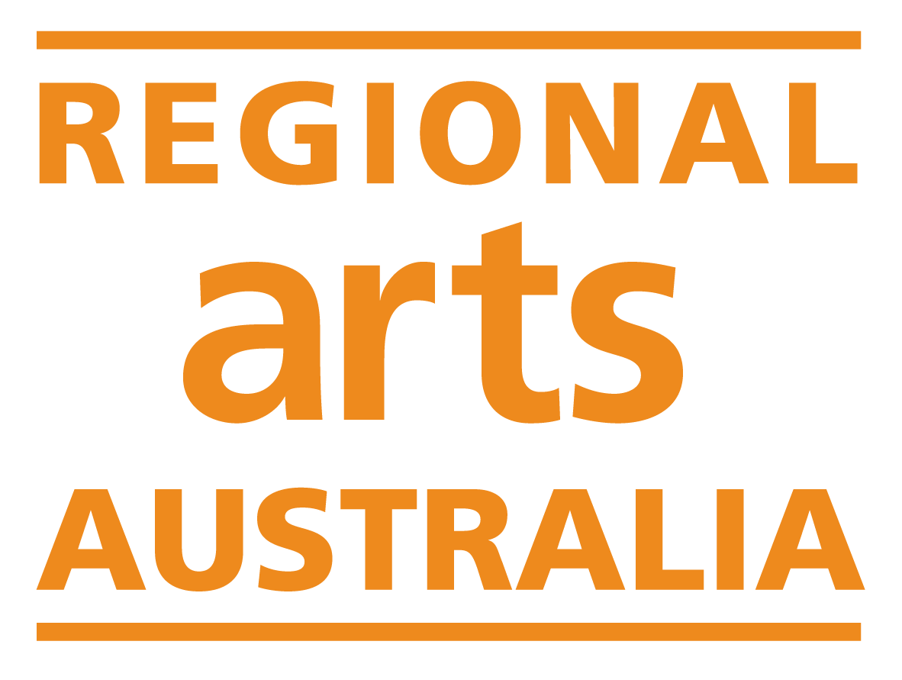

Summary of Guidelines

Regional Arts Fund Quick Response Grants

This is a supplementary document to the official guidelines to assist with interpretation. In the event of any inconsistency between this summary and the guidelines, the official guidelines will be the basis for all decisions.

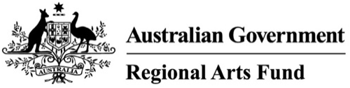

The Regional Arts Fund is an Australian Government program that supports sustainable cultural development in regional and remote communities in Australia.

About the Regional Arts Fund
The Regional Arts Fund (RAF) is an ongoing Australian Government program that supports artists, arts workers and communities in regional and remote Australia.
Each year, the program provides around $6 million to support arts and cultural activity across the country. It is part of the Australian Government’s Arts and Cultural Development Program, which aims to increase participation in, and access to, arts and culture. RAF recognises that regional and remote arts practice is essential to a strong and diverse national arts sector. It supports creative work that reflects local stories, strengthens communities, and contributes to regional economies.

National Context
The Regional Arts Fund aligns with Revive: a place for every story, a story for every place, the Australian Government’s five-year plan for the arts and cultural sector.

Revive focuses on:
- First Nations First
- A place for every story
- Supporting artists as workers
- Strong cultural infrastructure
- Engaging audiences

Through this, the Regional Arts Fund helps ensure that artists, organisations and communities in regional and remote Australia can thrive, grow and stay connected to national cultural life.

How the Program Is Delivered
The Regional Arts Fund is managed by Regional Arts Australia on behalf of the Australian Government.
Grants are delivered locally through Regional Arts organisations in each state and territory (known as Regional Program Administrators). These organisations:
- run funding rounds
- assess applications
- award grants to artists and communities
Each year, at least $2.7 million is distributed through open, competitive grant rounds.

What the Fund Supports
The Regional Arts Fund supports projects and opportunities that:
- strengthen regional communities through arts and culture
- build partnerships and collaboration
- increase access and participation in the arts
- support artists’ careers and professional development
- deliver high-quality, viable creative outcomes

Two Ways to Apply
There are two types of grants available through the Regional Arts Fund. Each supports different kinds of activity.

1. Quick Response Grants
Quick Response Grants support small, time-sensitive opportunities. These are for activities that:
- come up unexpectedly
- need to happen soon
- are smaller in scale
For example:
- attending a workshop or training
- taking up a short-notice opportunity
- delivering a small, immediate project
These grants are quick to apply for and quick to assess, with a streamlined process.

2. Project Grants
Project Grants support larger, more developed projects. These are for activities that:
- take more time to plan
- involve deeper community engagement
- have longer-term outcomes
For example:
- creating new work
- running a community arts project
- delivering a multi-stage program
These grants require more detailed planning and application information.

Which One Should You Apply For?
A simple guide: If your opportunity is urgent, small, or unplanned - apply for a Quick Response Grant. If your project is larger, planned, and longer-term - apply for a Project Grant

Support Available
If you’re unsure which grant is right for you, or need help applying, contact your state or territory Regional Arts organisation.They can:
- talk through your idea
- help you choose the right grant
- support you with your application

Quick Response Grants

1. About the Quick Response grants program
Quick Response Grants support small, time-sensitive arts opportunities for artists and arts workers in regional Australia. These grants are designed for opportunities that:
- arise unexpectedly
- cannot be planned in advance
- cannot wait for a larger funding round

For example:
- attending a professional development opportunity
- taking up a short-notice creative opportunity
- delivering a small, immediate arts activity

2. How much you can apply for
- Individuals: up to $3,000
- Organisations: up to $5,000

In some very remote areas, higher amounts may be considered.

3. Who can apply?
You can apply if you are:
- an individual artist or arts worker
- a group or organisation
- based in regional or remote Australia (eligible locations MM2-MM7, see below)
- Over 18 years of age. Note: If you're under 18, you can still apply however, your application must be supported by an adult (18 or over) who has an ABN and agrees to manage the funding on your behalf.

Your project must:
- Have an immediate need
- primarily benefit a regional or remote community

Projects can take place anywhere in the world, however as the applicant you must be based in an eligible location (MM2–MM7)

What is an Eligible Location (MM2–MM7)?
To check if you are based in an eligible location, visit the Regional Arts Fund Eligibility Map and enter the address under which your ABN is registered. If you do not have an ABN, you will need to be auspiced by an organisation based in an eligible location.

4. What you can use the Quick Response grant for
You can use the grant for:
- artist fees (fair pay required, using NAVA, MEAA or LPA rates)
- travel and accommodation
- materials and equipment
- venue hire
- accessibility costs
- project administration costs

5. What this grant supports
The Quick Response Grants supports immediate or short-notice opportunities, such as:
- professional development
- skill-building opportunities
- small-scale arts activities

It does not support:
- long-term or large-scale projects
- activities that can wait for Project Grants
- Projects primarily benefitting a major city or metro location (MM1)
- Competitions, prizes or awards
- curriculum -based activities, including for primary, secondary or tertiary courses
- ongoing core administration costs for an organisation (e.g. infrastructure or building fit-out costs)

6. How applications are assessed
Your application will be assessed based on the following criteria:
- Impact – What difference will your idea make?
- Community & Partnerships – Who is involved or supporting it?
- Reach – Who will benefit or participate?
- Opportunity – How does this support artists or skills?
- Quality & Viability – Is your idea realistic and well planned?

All criteria are equally important.

A simpler way to think about the criteria
Instead of five separate sections, think about:
- What are you doing? Why now?
- Who benefits?
- Why are you the right person to deliver it?
- How will you deliver it?

8. How to apply
Applications are submitted online.

For the best chance of success, we strongly recommend that you contact your State or Territory Regional Program Administrator before submitting your application. Their details are at the end of these Guidelines. They can help you check if your idea is a good fit and answer any questions you may have.

For your application, you will need:
- a title for your activity
- a short project description (no more than 50 words)
- a simple budget
- support material

9. Application questions
- Question 1: What do you want to do and why? [responds to Opportunity / Impact / Reach criterion]. (300 words)
- Question 2: Who is involved in your project and how will they benefit from it? [responds to Support & Partnerships criterion] (300 words)
- Question 3: How will you make it happen? [responds to Quality & Viability criterion] (300 words)

10. Key dates and timing
Quick Response Grants are designed to be flexible and available year-round.
- Applications can be submitted through your state or territory Regional Program Administrator
- Applications are accepted from February to November and are assessed at the end of each month
- You will find out the outcome of your application within 5 business days of the closing date

When can projects start?
- Quick Response activities must begin between 2 and 12 weeks from the closing date of the round

11. Accessibility
We aim to make this grant:
- quick to apply for
- easy to understand
- accessible to first-time applicants

You can ask for support with your application, communication, or project delivery. This may include help completing the form (e.g. a scribe), alternative formats (such as large print, audio or video formats), interpreting services (including Auslan or language translation), support workers or access assistants, and costs to make your project accessible for participants and audiences.

If you need support or have questions, contact your state Regional Arts organisation.

12. Contact details
Depending on where you are based, you can contact your Regional Program Administrator for more information or support.

Australian Capital Territory
artsACT
artsACT@act.gov.au
02 6207 2384

New South Wales
Regional Arts NSW
funding@regionalartsnsw.com.au
02 9270 2500

Northern Territory
Darwin Community Arts
raf@darwincommunityarts.org.au
08 8945 7347

Queensland
Flying Arts Alliance
raf@flyingarts.org.au
07 3216 1322

South Australia
Country Arts SA
grants@countryarts.org.au
08 8444 0400

Tasmania
RANT Arts
grants@rantarts.com
03 6331 8232

Victoria
Regional Arts Victoria
grants@rav.net.au
1300 882 531

Western Australia
Regional Arts WA
investment@regionalartswa.org.au
08 9200 6200

